

Senior Design
ENG EC 463
Boston University Electrical & Computer Engineering
The Triton Test Report

Team 25

Required Materials

Hardware:
- Raspberry Pi 3B
- USB-A to Micro cable
- Wall Block supplying 5V and 2.4 Amps DC OR 5V Rechargeable Battery
- Flora Wearable Ultimate GPS Module
- OAK-D S2
- iPhone
- Lightning to USB-C cable
- Mac

Software:
- GPS C++ Script
  - Record, parse, and place GPS data into a file
- Bluetooth Python Script
  - Connect the Triton (Raspberry Pi) to the iOS app
  - Read from the GPS file and send data via Bluetooth to the iOS application
- Camera Distance Recognition Python Script
  - Determine object distance
  - Alert if an object is within a certain distance relative to the camera
- iOS Application
  - Receive GPS data via Bluetooth from the Triton (Raspberry Pi)
  - Present the GPS data on the phone screen

Setup

There are two separate portions of our prototype: the iPhone running an iOS application and the Raspberry Pi running a Bluetooth GATT server, driving the GPS, and sending the GPS data over to the iPhone application via BLE. The GPS module is connected to the Raspberry Pi via UART.

Pre-Testing Setup:

Raspberry Pi
- Flash the Raspberry Pi 3b’s SD card with the Raspberry Pi OS 64-bit image
- Clone our git repository onto the pi
- Activate our virtual environment
- Open the /Senior-Design-Sailboat-Nav-2025/RPI-BLUETOOTH/ folder
- Run the bluetooth.py script (python3 bluetooth.py)

iPhone/Mac
- Download XCode
- Clone git repository
- Open the /Senior-Design-Sailboat-Nav-2025/Triton/ folder in XCode
- Connect iPhone to Mac via lightning to USB-C cable
- Put iPhone in Developer Mode
- Make sure that the app signature is a trusted developer in the iPhone running the app
- Press the play button in the top left corner of XCode

GPS
- Enter the Raspberry Pi configuration
- Select “Interface Options”
- Select “I6 Serial Port”
- Disable the login shell
- Enable the serial interface

OAK-D
- Install depthai and the necessary dependencies
- Plug into Raspberry Pi/Laptop
- Activate our virtual environment
- Open the /Senior-Design-Sailboat-Nav-2025/OAK-D/ folder
- Run the optimized.py script (python3 optimized.py)

Testing Procedure

Circuit Diagram
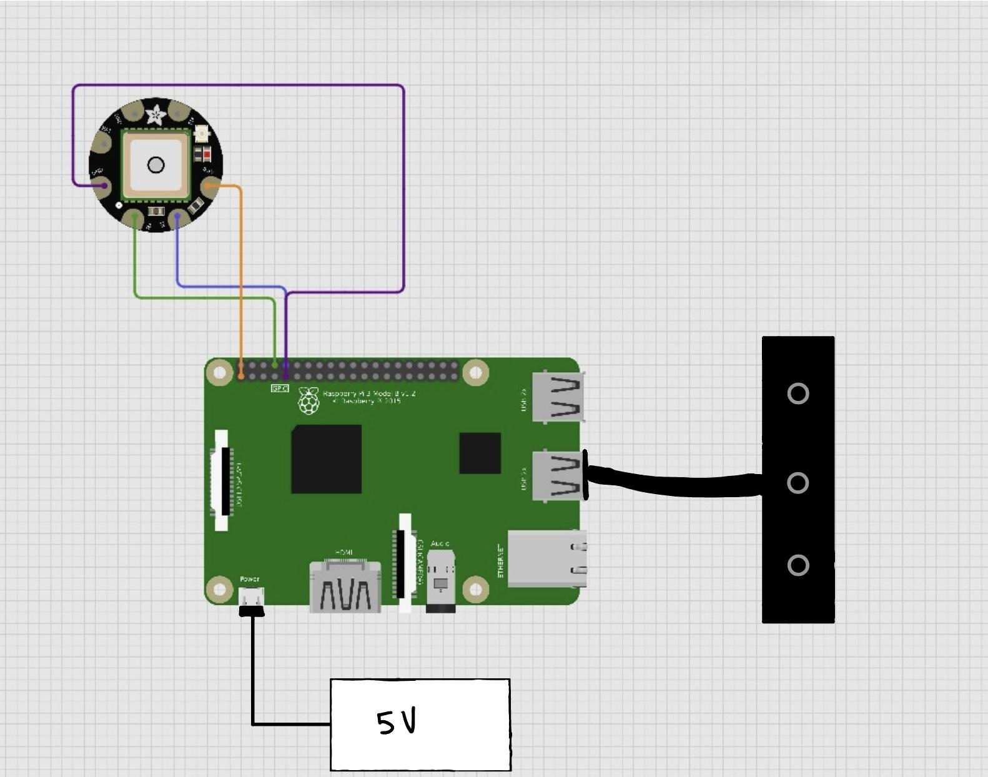

Hardware Pinout
Raspberry Pi | Peripheral
Pin 1, 3.3V | GPS 3.3V
Pin 9, GND | GPS GND
Pin 8, TX | GPS RX
Pin 10, RX | GPS TX
USB Port | OAK-D

Camera:
- Run the Python script for object detection (python3 optimized.py)
- Hold the camera at a fixed position
- Place someone in front of the camera from a set distance
- Have them slowly approach the camera
- The live feed on the monitor will show that the person is getting too close and will display the person’s distance from the camera
- Have the person slowly walk away from the camera and observe as the warnings on the monitor go away

GPS:
- Take the GPS outside to get a fix, and wait until the GPS module stops blinking every second
- The iOS application will auto-connect to the Triton (Raspberry Pi)
- Observe the data collected as it is displayed in the iOS application

Measurable Criteria

- The OAK-D camera will show a live view with an ROI (region of interest) grid to showcase if an object is too close on the Raspberry Pi through a monitor
- The OAK-D camera will print which ROI detects an object that is too close and its distance from the camera on the Raspberry Pi
- The GPS should receive a signal (fix) outside and record relevant information:
- The GPS will parse and place desired data in a .txt file on the Raspberry Pi
  - This includes: UTC Time, Longitude, Longitude Indicator, Latitude, Latitude Indicator, and Altitude
- The Triton (Raspberry Pi) connects to the ios app via an internal Bluetooth module, discovers the GPS service, and subscribes to notifications on the GPS service’s characteristics
- The app will receive and present the GPS data

Score Sheet

Task | Completion (Y/N)
OAK-D displays a live feed | Y
OAK-D has a grid showing distances | Y
OAK-D grid changes color as an object approaches | Y
OAK-D prints out a message that an object is too close with its distance | Y
OAK-D updates the color and stops printing when the object is far enough away | Y
GPS is able to get a fix | Y
Phone is able to detect and connect to the pi | Y
Data is uploaded and visible on the app | Y

Conclusions

This lab test aims to showcase a proof of concept demonstrating the workflow of our design. Our product aims to utilize various sensors and send their data to an application on an iPhone. The demonstration with the GPS module showcases a real-time example of what our product will look like in action. It exhibits how fast the app will update the GPS’s data and an early visual of how that data will be presented. The demonstration with the OAK-D camera displays a practical and potential application of its features utilizing its object detection and depth perception capabilities as well as a live-feed view. This is relevant since the OAK-D will be placed on the bow of the boat and is responsible for providing the sailor a clear view from the front of the boat since their vision can be obstructed due to the sails and mast while sailing. Additionally, it can be difficult to safely dock and avoid hitting anything with the bow. The live view will aid the sailor in avoiding obstacles and the live alerts of nearby objects can be turned into auditory signals for if the sailor does not notice something. While the final product will include a more refined system with more sensors, this demonstration establishes a model for the development of our product into its final stages.

